Preparation of the Article’s Manuscript Using the Template «J_Nano_Electron_Phys_ENG.dot»

T.V. Lyutyy¹,, A.Yu. Polyakov¹,^{2,}

¹ Sumy State University, 2, Rimsky-Korsakov Str., 40007 Sumy, Ukraine
² Sumy Information Technology Center, 28, Shevchenko Ave., 40007 Sumy, Ukraine

(Received 15 February 2013; revised manuscript received 14 April 2013; published online 15 July 2013)

The paper describes the design features of the text manuscripts in the word processor MS Word MS Office 2003 and 2010 releases. Use of the standard tools of the MS Word environment and equation editors Equation 3.0 and MathType 6.x are examined. Much attention is paid to utilizing of the special styles designed just for the articles in the Journal of Nano- and Electronic Physics. The work is aimed to explanation of the techniques of article text formatting during the writing to maintain appropriate standards of printed and electronic versions of the Journal.

Keywords: MS Word, Template, Style, Font, Menu, Equation, Figure, Reference, Table.

DOI: | PACS number(s): 00.00.Хх, 00.00.Хх
(Please, input Your PACS and delete this hint)

- POLICY OF THE JOURNAL

The Editorial Team of the Journal of Nano- and Electronic Physics is working permanently at the improvement of the authors’ service, acceleration in the publication of submitted papers, good technical support, and worldwide dissemination of published articles. For this end The Editorial Team translates Ukrainian and Russian articles into English, constantly develops the own web resource http://jnep.sumdu.edu.ua/ for the distribution of the articles in the Internet and for the comfortable electronic submission of articles’ manuscripts. Publication of articles, translation from Ukrainian (Russian) into English, and all author services are absolutely free. All articles (and their English versions) are freely available on-line. From the moment of the manuscript submission the Editorial Team keeps contacts with the authors, and before issuing sends an electronic proof copy.
Nevertheless, firstly, the Journal is peer reviewed, and any submitted manuscript undergoes the reviewing procedure. If the referees decline the paper, it could not be published. Secondly, strict requirements to the manuscript preparation exist, and submitted manuscript should be ready for publication. Simultaneously with the content reviewing, any manuscript is checked for compliance to the stated formatting requirements. If the checking is failed, the manuscript is returned to authors for revision.

- MOTIVATION of the template usage

  - The Concept of Template

A template is a tool for enforcing a standard layout and look and feel across multiple pages or within content regions. It provides stricter standardization control of the documents. In other words, a template is a form or pattern used as a guide to making something. Due to it you do not need set the margins, spacing, page layout, fonts, format options, etc. every time.
The template J_Nano_Electron_Phys_ENG.dot is a filled form. Its text content is the authors’ guidelines formatted in full accordance to the formatting rules. Your own article text should be typed over and instead of this text.
When the file with extension «dot» is opened, the word processor MS Word generates a new document file, and copies automatically the template content into it. All further editions will be done in this new file, however a dot-file remains unchanged. It gives a good opportunity for replication.
The main advantage of the template is the text formatting standardization independently on the WS Word version, its current settings, the scope and personal preferences of the authors. The text given as an example provides with excellent visual concept relatively to the article preparation. It is more preferred than the detailed description of a large set of formatting options and prevents a number of misunderstandings between authors and editors. If, moreover, all below listed requirements are met by all authors, all submitted articles will be ready to issue without significant additional edits.

  - Use of the Styles

Structure of the J_Nano_Electron_Phys_ENG.dot Template corresponds to the article’s one and the text formatting practically in full is realized due to the using of special styles designed for the articles in the Journal of Nano- and Electronic Physics. Let us describe the Style concept in detail.
The styles of the MS Word make essentially easier the formatting of your document. A style is a set of formatting characteristics that you can apply to text in your document to quickly change its appearance. For instance, the style may include Century SchoolBook font, size 9 pt, indent 0.5 cm, single line spacing, and alignment on both sides. When you apply a style, you apply a whole group of formats in one simple task. The text formatting using the style is much faster than manual formatting of each item. In addition, it ensures a consistent look of all identical elements in the document. If you later change the style, the text of the document, to which this style was applied, will be changed automatically. Here and below we mean a paragraph style.
Typically, users ignore special styles, and prefer to use the default style «Normal», and change the text parameters manually. Due to this, the appearance of the style «Normal» for different desktops is significantly different. During the editorial handling of the Journal issue all formatting parameters are brought into conformity with default styles on the editor’s desktop. Thus, there is a situation when initially authors prepare the text in the proper form, and then editor repeats the same work. Therefore, the use of standard styles («Normal», «Main text paragraph», etc.) is not suitable for the article preparation. The creation of special styles by authors is not a rational way as well, because this adds troubles both to authors and editors.
An easy and natural solution of these problems is the creation of the special styles by the Editorial Team. All authors will use but not change them. These are the styles that are contained in the J_Nano_Electron_
Phys_ENG.dot Template and will be contained in all documents created using this Template. All these styles have a special name that starts with letter combination «Jnep_».
The special styles are also necessary for the automatic analysis and reliable harvesting of metadata with further formation of the Journal web-version and data transfer to the abstract databases, which index our Journal.
To format the text in accordance with the required style in MS Word of MS Office 2003, it is necessary to select a part of the text and choose one of the styles in the corresponding list on the formatting toolbar (see Fig. 1a). You can also choose the style from the menu «Format»-«Styles and Formatting» (see Fig. 1b).
In MS Word of MS Office 2010 an access to the styles is provided by the menu «Home»-«Style» with the activation of the style’s dialogue (by clicking the icon at the bottom right corner of the menu «Styles»), see Fig. 2, or via keyboard shortcut «Alt» + «Ctrl» + «Shift» + «S».

- Article Structure and the corresponding Styles

The basic used style is called «Jnep_Normal», and other styles are its subsidiaries (see Table 1). Absolutely the whole text of the article should be formatted with the styles, which have the prefix «Jnep_» in the name. It is PROHIBITED to edit and modify these special styles. To correctly apply the styles, it is necessary to display all non-printable characters (the button with the sign «¶» on the toolbar or the keyboard shortcut «Ctrl» + «*»), which serve for the formatting, namely, space character, paragraph, end of line, page breaks, etc. One should be very careful while removing non-printable characters because they are important elements of the formatting.
«Jnep_Normal» style uses Century SchoolBook font, which is not a standard Windows font and should be installed additionally. The installation details of this font are described in Appendix A.
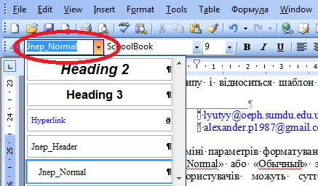

a

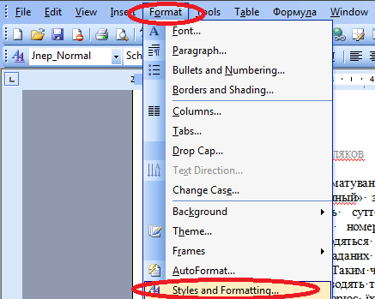

b

Fig. 1 – Application of the styles for the text formatting in MS Word of MS Office 2003 using the «Formatting» toolbar (a), via the menu «Format» (b)

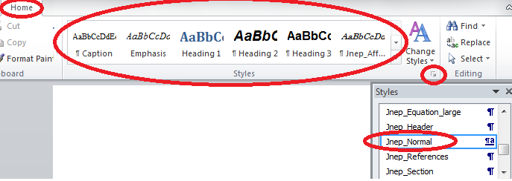

Fig. 2 – Application of the styles for the text formatting in MS Word of MS Office 2010

  - Headers and Footers

Headers and footers are the areas in the top and the bottom margins of each page of the document. You can insert text or graphics in headers and footers, for example, the Journal name, volume, issue, the article ID (or page numbers), Publisher information, etc., which are printed at the top or the bottom of each page of the document. In particular, the header specifies the article title (or abbreviated title) and the authors list (or abbreviated list). These parts of the header can be edited by authors. If necessary, authors should create by themselves the abbreviated title of their article, which must fit one line of the header. Also the list of authors should be typed in one line In addition, if the list is abbreviated, «etc.» should be added at the end.
The style, which is used to format the headers and footers, is «Jnep_Header».

Table 1 – Description of the special paragraph styles

№ | Style Tytle | Destination | Notes
1 | Jnep_Normal | The main paragraph style. Used to format:  a) the blank lines separating the title, authors, affiliations and dates;  b) the main text of the article. | This style is basic. Other styles are its subsidiaries.
2 | Jnep_Title | For the article title formatting only.
3 | Jnep_Authors | For the list of authors formatting only.
4 | Jnep_Affiliations | For the list of affiliations formatting only.
5 | Jnep_Abstract | Used to format:  a) the abstracts;  b) the keywords.
6 | Jnep_Empty_string | Used to format the blank lines separating:  a) the Figures and captions to them;  b) the Tables and captions to them;  c) the titles of sections (subsections) and the main text.
7 | Jnep_Equation | Used to format the mathematical expressions written out in a separate line. | Tab is typed before and after the equation.
8 | Jnep_Equation_large | Used to format the mathematical expressions written out in one column. | Tab is typed before and after the equation.
9 | Jnep_Header | Used to format the headers and footers.
10 | Jnep_Caption | Used to format the captions to Figures and Tables.
11 | Jnep_References | Used to format the reference list.
12 | Jnep_Section | Used to format the titles of sections. | Styles 12 and 13 are connected by multilevel numbering.
13 | Jnep_Subsection | Used to format the titles of subsections.
14 | Jnep_Section_NonNum | Used to format the appendix titles, «Acknowledgement» and «References».

  - Article Title

The title of the article should concisely and fully describe the content of the article. In the title the following is undesirable:
1. the word «research» and its synonyms;
2. mathematical expressions;
3. abbreviations.
The title should be separated from the list of authors below by a blank line of the style «Jnep_Normal».
The style used to format the titles is «JNEP_TITLE».

  - Author List

The list of authors is formatted using the style «Jnep_Authors». Each author is noted in the format «Abbreviated First Names»-NON-BREAKING SPACE-«Last Name». The non-breaking space (symbol «°») is typed using the keyboard shortcut «Shift» + «Ctrl» + «Space». Authors’ affiliations are designated by a superscript Arabic numeral at the end of last names. If all authors have the same affiliation, superscripts Arabic numeral are not used. After Arabic numeral the footnote symbol, which indicates the e-mail of the author, is inserted. This operation is carried out in MS Word of MS Office 2003 by using the «Insert»-«Link»-«Footnote» (see Fig. 3a) or with hot keys «Alt» + «Ctrl» + «F». The format of footnotes should conform to the specified ones shown in Fig. 3b. In MS Word of MS Office 2010 insert of the footnote is performed using the menu «Links»-«Insert Footnote» (see Fig. 3c) or hot keys «Alt» + «Ctrl» + «F». Access to the text of the footnote is carried out by pressing the left mouse button on the symbol after the author's name. Then cursor is moved down the page, and you print the appropriate e-mail. For more information about the list of e-mail addresses see the subsection 3.6.
The list of authors should be separated by a blank line of the style «Jnep_Normal» from the title and affiliation list.

  - Author Affiliation List

Explanation of indices in the list of authors pointing to the organization, on whose behalf the paper is submitted, should be as follows. First, the index in the form as well as after the author surname is typed. Then after the tab symbol one indicates the Organization Name, Building Number (or Code), Street (Avenue, Boulevard, etc.) Name (or Number), «Str.» («Ave.», «Boul.», etc.), Zip Code, City, and Country. Then in a new line the similar information corresponding to the next index is typed. This part of the text is formatted using the style «Jnep_
Affiliations» and must be separated from the list of authors and abstracts by a blank line of the style «Jnep_Normal».

  - Dates

Date of publication of each article is a very important part of the Journal issue. Since the web-version of the Journal Nano- and Electronic Physics precedes the print one, such a date is the date of the article posting on the Journal website. This fact is indicated in the list of dates. In addition, the principal stages of the article delivery, namely, the date of the first submission and the date of receipt of the final version are shown. All these statements are entered by the Editorial Team. The style used to format the list of dates is «Jnep_Abstract».
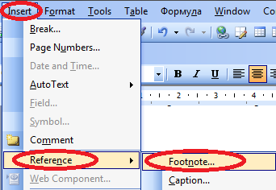
a

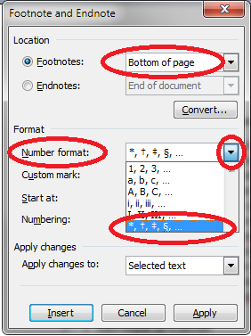

b

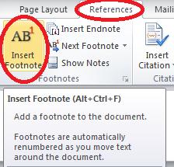

c

Fig. 3 – Insert of the footnote indicating the author's address: in MS Word of MS Office 2003 (a), the format of footnotes (b), in MS Word of MS Office 2010 (c)

  - E-mail List

For the Editorial Team and readers the most relevant is the address of the author for correspondence. Electronic addresses of the other co-authors should be included only in the case when the authors really need this. As noted earlier, in order to create the list of addresses it is necessary to use footnotes. Here in the footnote at the bottom of the page after the symbol, which corresponds to the index in the list of authors, the e-mail is typed. The style used to format the list of e-mail addresses is «Jnep_Normal».

  - Article Abstract

Abstract is an essential part of the article metadata. One should always remember that the main purpose of the abstract is to attract the target reader. The abstract is a start point of the article studying. Abstract is passed to the abstract database, where the automatic search is widely used. Therefore, the basis of the abstract should be a summary of key findings and research methods. The structure of this part of the text should be as simple as possible, namely, one (sometimes two) paragraphs of a total of 100-200 words. Authors should avoid the equations, symbolic notations, obscure acronyms, because they complicate the understanding and automatic search. The style to format is «Jnep_Abstract».

  - Keywords

An important tool for searching and structuring of scientific and technical information is the keywords that are pointed in the article. The automatic search on the Journal website, abstract databases and electronic catalogs is realized by the keywords mainly. Therefore, when writing keywords, it is necessary to choose exactly the words or phrases that are frequently found in the text and reflect the objects and methods of the study good enough. The symbolic designations should be avoided, obscure abbreviations and mathematical expressions are generally unacceptable. The total number of keywords should be in the range from five to ten. The style of the keywords list is «Jnep_Abstract».

  - РАСS Numbers

Physics and Astronomy Classification Scheme (РАСS) (see http://www.aip.org/pacs/) is internationally adopted, hierarchical subject classification scheme designed by the American Institute of Physics (AIP) in collaboration with International Centre for Scientific and Technical Information (ICSTI). As UDC, it is used to organize and easy navigate. But more narrow specialization of PACS gives advantages for use in the journals of physical profile. PACS numbers are typed after keywords in the right column of the table with invisible borders. If only one number is present, then instead of «number(s)» authors should type «number», if more –«numbers». List of PACS numbers can be downloaded from the Journal website.
The style that is used is «Jnep_Abstract».

  - The Main Content

Content of the main part should be logically related, set out clearly, prepared in scientific style, and have a corresponding structure. Authors shpuld remember that the content determines the volume of the article. It is approximately equal to: a) more than 12 pages for topical review, b) 5-10 pages for conventional problem-solution articles; c) 3 pages for research notes.
The basis of the structural separation of the article is sections and subsections. There are two styles «JNEP_SECTION» and «Jnep_Subsection», which are connected with multilevel numbering, for titles of sections and subsections.
Regardless of the article type, its content should have the following structure.
- Introduction. Typically, this element should be allocated in a separate section with the same name, which is formatted with style «JNEP_SECTION». An exception can be only for the articles like «research notes». Introduction to the article should be concise, but at the same time characterize the current state of the problem, highlights, and motivate the relevance of own research.
- Description of objects and investigation methods. The purpose of this element is a clear statement of the problem for the study, based on which the article was written. In addition, for theoretical studies the description of the models, analytical methods and approximations are desirable. If the article is written based on the results of numerical simulations, authors should mention the algorithms and methods, technical parameters of computing resources and software implementations, due to which the results were obtained. Finally, for experimental works one should provide description of the equipment and experimental conditions, specify materials and devices that were used.
- Results and Discussion. This item is intended for direct presentation of the investigation results. The last are presented in the form of mathematical expressions, plots, photographs, tables, etc. In this case the usual statement of the facts is not enough and the analysis is required. All numerical data should be presented in conventional units.
Depending on the length of the article, the objects and research methods, results and their analysis can be described in several sections; each of them may consist of subsections. The name of each section is formatted with the style «JNEP_SECTION», subsections – with «Jnep_Subsection». If authors find necessary the further structure partitioning of subsections, then sub-headings should be typed with style Jnep_Normal and numbered «by hand». If authors have the appropriate experience, they can continue to develop the existing two-level list starting from the third level.
- Conclusions. This item should be allocated in a separate section of the same name and formatted with the style «JNEP_ SECTION». Exceptions are the «research note» articles only. Findings should be substantiated and compared with the analogs, contain recommendations for their further implementation, etc. Abstract and conclusions should not duplicate each other.
- Acknowledgements. They are addressed to the institutions and foundations for financial support of the research, which is reported in the article, as well as to people or institutions for the provision of technical facilities to conduct experiments or calculations. Finally, authors can express the appreciation to scientists, who are not co-authors, for the results discussion. In all the cases, after the main article content in a separate section titled «Acknowledgements» authors specify the text of gratitude. The section name is formatted with style «JNEP_SECTION_NONNUM». The text of acknowledgements should be brief and contain the specific names, institutions, projects acronyms, etc.
- Appendixes. It is often necessary to present the technical details, which are desirable for a thorough perception of the article material, but have a secondary, technical role. Such cases can, for example, include the transformations of vector equations and their presentation in another coordinate system. For these purposes it is necessary to use additional sections at the end of the article before the references – the so-called appendixes. The title of each such section is formatted with the style «JNEP_SECTION_NONNUM». Each title should to be started with the word «Appendix» and numbered by the letters of Roman alphabet. Then, in a new line the name of Appendix is typed with the same style.

  - References

The numbering of references should be transparent, and the sequence of numbers in the list should correspond to a sequence of references in the manuscript text. References are marked in the text with square brackets [...]. The list is placed at the end of the article in a separate section entitled «References». The style used to format this section title is «JNEP_SECTION_
NONNUM», and for the list is «1. Jnep_References». References to the sources should be typed in the format adopted in the journals of the Physical Review series of the American Physical Society. Language of the references should correspond to the original.

3.11.1 References to the articles
For references to the articles in scientific journals this format has the following form:
«Abbreviated first names»-NON-BREAKING SPACE-
«Last Name»-COMMA-«Abbreviated Journal Name»-«Volume number»-«No»-«Issue number»-COMMA-«first page number (or article ID)»-«(Year)»-DOT.
Notes.
- The list of authors is represented in full.
- The non-breaking space (symbol «°») is typed using the keyboard shortcut «Shift» + «Ctrl» + «Space».
- The volume number should be bold and not contain the prefix «Vol.», etc.
- Number of Issue should be displayed in the case when the page numbers do not pass-through within one volume and begin with each new issue again.
- If the volume number is not specified, the number of issue is required and should be typed in bold.
- Abbreviated name of the journal is typed in italic and must comply with abbreviations according to ISI Web of Science (download a list of acronyms from the Journal website).
Examples of the references on the articles are [1-3].

3.11.2 References to the books
There are two formats for the book references. The first one is used if each of authors listed on the cover formally has the same rights and bears equal responsibility for the book. The format of the reference to the book in this case is schematically written as:
«Abbreviated first names»-NON-BREAKING SPACE-«Last Name»-COMMA-«Book Title»-(«Place of publishing»-COLON-«Publisher Name»-COLON-«Year»)-DOT.
If the book was published under the editorship of one or several persons and other authors were involved only into certain sections, the format of the reference to the book is the following:
«Book Title» («Ed» «Abbreviated first names»-NON-BREAKING SPACE-«Last Name»-(«Place of publishing»-COLON-«Publisher Name»-COLON-«Year»)-DOT.
The examples of the references to the books are [4, 5].
3.11.3 References to the preprints
Reference format for the electronic preprint is very simple:
«Abbreviated first names»-NON-BREAKING SPACE-«Last Name»-COMMA-«File (account) ID»-DOT.
In this case the File ID should be made as hyperlink to the relevant electronic resource. For example, see [6].

3.11.4 References to the patents
Reference format for the patent is the following:
«Abbreviated first names»-NON-BREAKING SPACE-«Last Name»-COMMA-«Pat.»-NON-BREAKING SPACE-«Patent number»-COMMA-«Country»-COMMA-«additio-nal patent code (if necessary)»-COMMA-«publ.» «date and ID of the bulletin»-DOT.
Examples are given as references [7, 8].

3.11.5 References to collections of scientific works
Reference format for collections of scientific works has a form:
«Abbreviated first names»-NON-BREAKING SPACE-«Last Name»-COMMA-«Title of Collection»-COMMA-«Article ID (if applicable)»-COMMA-«first page number» («Place of publishing»-COLON-«Publisher Name»-COLON-«Year»)-DOT.
For example, see Ref. [9].

3.11.6 References to the conference proceedings and abstracts
Format of the references to the conference proceedings is the following:
«Abbreviated first names»-NON-BREAKING SPACE-«Last Name»-COMMA-«Conference Title (abbreviated conference title)»-COMMA-«Article ID (if applicable)»-COMMA-«first page number» («Place of publishing»-COLON-«Publisher Name»-COLON-«Year»)-DOT.
For example, see Ref. [10].
References to the abstracts of conferences are undesirable, because the format of abstracts is uninformative; abstract books, as a rule, are inaccessible, and the results reported at conferences are generally published in the journal articles or conference proceedings. However, if authors still want to refer to the abstract books, the reference format is fully consistent with the format of the references to the conference proceedings.

3.11.7 Other References
Other references are extremely undesirable.

3.11.8 Endnotes usage
To work with the references, the authors, which have the relevant scope in the MS Word, can use the endnotes («Alt» + «Ctrl» + «D»). However, the format of endnotes should be appropriate, they must not appear as a superscript, and a horizontal line before the reference list should be deleted or hidden.

- Equations

  - Arrangement of the Equations in the Text

Mathematical expressions are placed directly in the text or typed in a separate line if formula is too cumbersome or important. In the case of existing the references to the expression (which is placed in a separate line) further in the text it should be numbered. The numbering of formulas can be cross-cutting across all sections or two-level, where the first level is the number of section, and the second one begins anew with each new section. To enumerate the equations as well as for further references to them, the authors with relevant experience can use the equation editor MathType 6.х tools (see sub. 4.3).
The style for formatting mathematical expressions arranged in a separate line is «Jnep_Equation». In addition, each such expression is separated above and below from the rest of the text by a blank line with style «Jnep_
Empty_string».
Each variable in expression denoted by the letter should be described in the explication immediately after expression. Explication should be typed as a continuous text without arrangement of each new variable in a new line. The order of variables in explication must correspond to the order of variables in expression. The corresponding example is the following:

, (4.1)

where is the force, m is the mass, is the acceleration.
For formulas located in the text (not in a separate line) authors should always ensure that the formula relates to the rest of the text. So, one should use a pipe instead of a horizontal shot. For example, is very poorly positioned in the text due to large intervals between the lines and therefore it must be replaced by .

  - Use of the Symbol Table

Simple mathematical expressions and individual characters should be typed EXCLUSIVELY using the symbol table (see Fig. 4a). Access to the latter is provided by menu «Insert»-«Symbol». The difference in the appearance of this menu in MS Word of different versions is shown in Fig. 4. It is important to note that the font of the inserted symbols must be «Symbol» (see Fig. 4a) or «Cambria Math» depending on what font is used in the special equation editors. For convenience, the most frequently used symbols can be assigned to hotkeys.
Notes.
- Variables and numbers should be separated from the operation symbols by non-breaking space («Ctrl» +
+ «Shift» + «Space»).
- Variables marked by the letters of the Roman alphabet and lower case letters of the Greek alphabet in addition are formatted in italic («Ctrl» + «I»).
- Variables denoting vectors and matrices should be formatted in bold («Ctrl» + «B»).
- Signs of mathematical operations, numbers, brackets, and large Greek letters should NOT be formatted in italic.
- The sign «minus» (–) should be different from a hyphen (-). Use hotkeys «Ctrl» + «-» (on a small keyboard) to type it.
- Sign «equal» (=) should be inserted from symbol table.
Examples of typing the formulas from the keyboard and symbol table are the following:

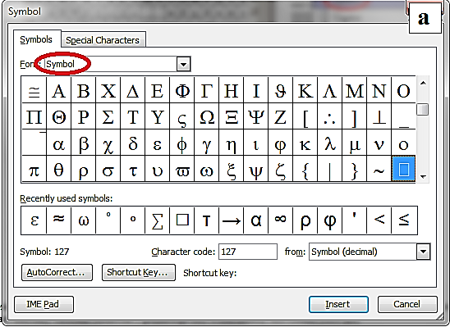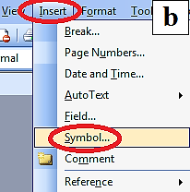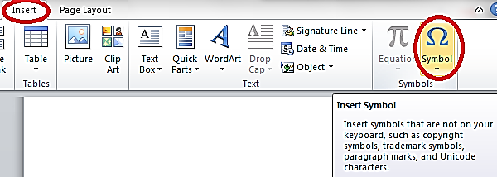
a
b
c

Fig. 4 – Insert of a symbol from the symbol table: symbol table view (a), activation of the symbol table menu in MS Word of MS Office 2003 (b), activation of the symbol table menu in MS Word of MS Office 2010 (c)

  - a = mH_{a}/2k_{B}T,
  - κ_{p} = 2a|ω₍₀₎₁ – ω₍₀₎₂|/A²(ω₍₀₎₁ + ω₍₀₎₂),
  - ϕ_{1,2} = ω_{(0)1,2}t + θ_{1,2}.

  - Using of Special Equation Editors

Special editors of formulas provided by the MS Word should be used only when the typing of mathematical expressions in the correct form from keyboard and symbol table is too difficult or impossible. The latter includes, for example, the super- and subscript simultaneously, the sign of the vector under variable, etc.
Note that the Equation Editor in MS Word of MS Office 2003 and 2010 are significantly different. Thus, MS Office 2003 uses the editor Equation 3.0, which is activated by the menu «Insert»-«Object»-«Object Microsoft Equation 3.0» or with hotkeys («Ctrl» + «Alt» + «Q»). You can also use the button with icon «» placed on the toolbar using the menu «Settings»-«Commands»-«Insert»-«Equation Editor» (see Fig. 5).
In order to match the symbols in formulas for the size of the article text, you need to activate the size configuration dialog in Equation 3.0 by the menu «Size»-«Define» (see Fig. 6a). Then in this dialog you need to set the following size parameters: Full – 9 pt, Subscript\Super-script – 65 %, Sub-Subscript\Superscript – 42%, Symbol – 110 %, Subsymbol – 86 % (see Fig. 6b).
To match in font the characters in mathematical expressions for the article text, you need to activate the style dialog in Equation 3.0 using the menu «Style»-«Define» (see Fig. 7a). Then in the given dialog you need to set the font Century SchoolBook for text, function, variable, matrix-vector; Symbol (or Cambria Math) for Greek letters. Also choose italic format for variables and bold for matrices and vectors (see Fig. 7b).
Equation Editor in MS Word of MS Office 2010 is launched by the menu «Insert»-«Formula» (see Fig. 8) or by combination of keys «Alt» + «=». Settings of this Editor are limited and do not let change the font or size of expressions: the font Cambria Math is automatically set and sizes automatically correspond to the main text.

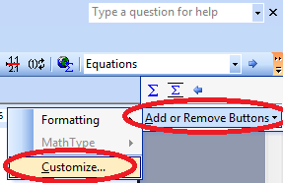
a

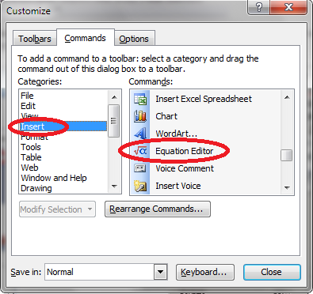
b

Fig. 5 – Addition of the Equation 3.0 button in MS Word of MS Office 2003: activation of the dialog «Options» (a) and choice of the button «» (b)

Incompatibility in formulas typed in two Editors is one of the main inconveniences while editing scientific texts in different versions of MS Office. A good way to overcome this problem is to use the equation Editor MathType 6.x. It is compatible with all versions of MS Office and has some additional features, which are useful for scientific text editing. All settings of MathType 6.x and the launch way are similar to Equation 3.0.

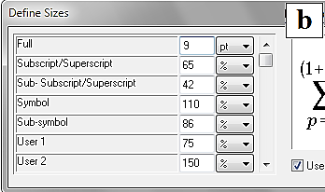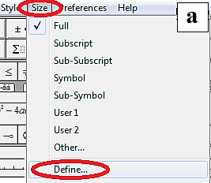

b
a

Fig. 6 – Launch of the size dialog in the equation Editors Equation 3.0 and MathType 6.x (a), definition of the size parameters (b)

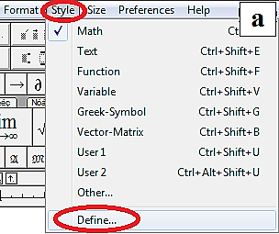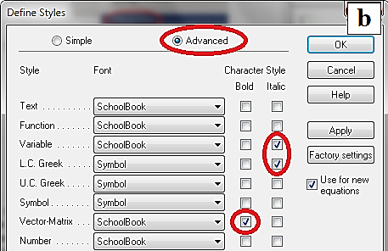
a
b

Fig. 7 – Launch of the style dialog in the equation Editors Equation 3.0 and MathType 6.x (а), definition of the style parameters (b)

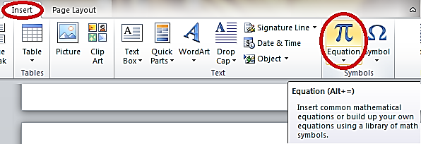

Fig. 8 – Launch of the equation Editor in MS Word of MS Office 2010

  - Insert of Large Equations

If mathematical expression is too cumbersome and cannot be inserted in one column, you need to type it in the full width of the page. To this end the one-column section should be created. The easiest way to create such section is the usual selection of the text and setting of the one-column format for it. To do this in MS Word of MS Office 2003, use the menu «Format»-«Columns» (see Fig. 9a). The corresponding dialog is presented in Fig. 9b. Similarly, in MS Word of MS Office 2010 the abovementioned manipulation is realized via the menu «Page Layout»-«Columns» (see Fig. 9c). In this case two extra section breaks will be created. Please, do not delete them!
The expression typed in a new section should be formatted with the style «Jnep_Equaion_large» and separated on the top and the bottom by an empty string with style «Jnep_ Empty_string». The corresponding example is:

. (4.2)

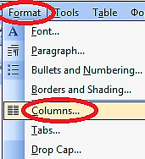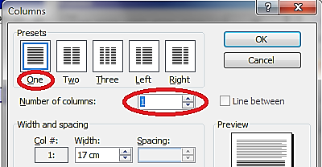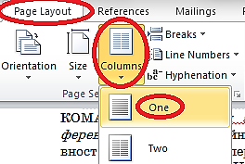

a b c

Fig. 9 – Launch of the Columns dialog format (a) and the appearance of this dialog in MS Word of MS Office 2003 (b), formatting of columns in MS Word of MS Office 2010 (c)

- FIGURES

Figures should be centered in a column. The caption is placed below the figure; its alignment is carried out by the width of the page. If caption is not more than one line, center alignment is permitted. Figures should be numbered. Numbering of figures may be cross-cutting across all sections or two-level, where the first level is the number of section and the second one begins anew in each new section. The caption format is: «Fig.»-NON-BREAKING SPACE-«Figure number»-EM DASH-NON-BREAKING SPACE-«Caption». The content of the caption should not repeat the description of the figure in the text. The caption style is «Jnep_Caption». Each figure is separated from the rest of the text above and below by a blank line with the style «Jnep_Empty_
string». The caption insert inside the text box («Drawing»-«Text Box» toolbar for MS Word of MS Office 2003 and «Insert»-«Text Box» for MS Word of MS Office 2010) is PROHIBITED. Also it is undesirable to use tables with invisible borders to group figure and the corresponding caption.
There are two ways for the text wrapping figure, namely, «In Line Text» and «Top and Bottom», which are defined by the menu «Picture Tools»-«Format»-«Text Wrapping» in MS Word of MS Office 2010 (see Fig. 10a). For version of MS Word of MS Office 2003 the text wrapping is completed via the context menu (which is launched by pressing the right mouse button, see Fig. 10b). Then choose the dialog «Format Object» (see Fig. 10c) and «Advanced Layout» (see Fig. 10d). Access to the parameters of text wrapping in MS Word of MS Office 2003 can be also done via the toolbar «Drawing» and «Adjusting image».
There are two ways for the figure design. The first one is to create it in other applications and import in the text using the menu «Insert»-«Picture» in MS Word of MS Office 2010 or the «Insert»-«Picture»-«From File» in MS Word of MS Office 2003. In this case you only need to import a BITMAP satisfying the following requirements. Figures should be:
- with resolution at least 300 × 300 dpi;
- in usual file format (JPEG, GIF, TIFF, PNG, etc.);
- sharp, contrast, and free from technical defects, which have no semantic load;
- not contain large margins;
- with designations and labels made exclusively by Roman or Greek letters, with the style close to other text styles, well-separated and conveniently positioned on the graphical part of the figure.
Insert of a vector figure from any Editor of vector graphics (e.g., Corel Draw) or graphing software (e.g., Sigma Plot) by copying to the clipboard is not allowed. Exceptions are possible only for the products of MS Office (e.g., MS Excel).

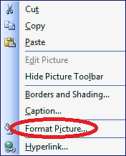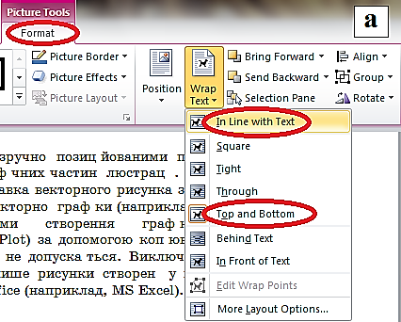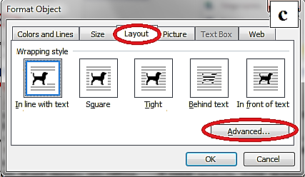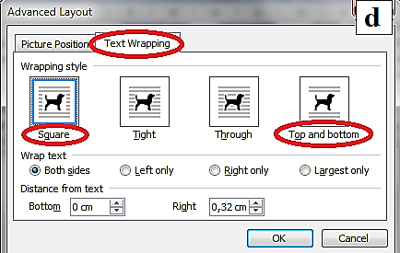
а
b
c
d

Fig. 10 – Determination of the text wrapping image: menu «Text Wrapping» in MS Word of MS Office 2010 (a), context menu (b), dialog «Format Picture» in MS Word of MS Office 2003 (c), dialog «Advanced Layout» in MS Word of MS Office 2003 (d)

The second way is to create a schematic figure using the drawing MS Word tools: toolbar «Drawing» for MS Word of MS Office 2003 or «Insert» for MS Word of MS Office 2010. This approach is undesirable and is allowed only for experienced users with the appropriate skills. Elements of the figure, which is created in this way, should be accurate, free from large empty margins and grouped into one object.
It is also permitted to edit the imported bitmap figures and add new elements to them using the MS Word drawing tools. For example, you can use the text box to create the labels (toolbar «Drawing»-«Text Box» for MS Word of MS Office 2003 and «Insert»-«Tex Box» for MS Word of MS Office 2010). The size label should be as small as possible for the selected font size and it should be successfully positioned over the figure and grouped with the latter.
If figure consists of several parts, each of them should be labeled with the letter of the Roman alphabet. Every part of the figure should be descripted in the caption using the literal labels. Letters may be listed under figure. For the center positioning of the letters below the figure the tabs should be used (see, for example, Fig. 11). Another way is to use the text boxes with the letters over the figures. For example, in Fig. 10 for letters 'a', 'b', 'c', 'd' this approach was used. If you ungroup this figure, these text boxes can be used for your figure.
Too cumbersome figures are inserted in a way described in subsection 4.4.

- Tables

Insert of a table into the article text is permitted only with the appropriate tools of MS Word, namely, dialogs of menu «Table» for MS Word of MS Office 2003 (see Fig. 11a) and «Insert»-«Table» for MS Word of MS Office 2010. Do not insert the bitmap image of the table created as a snapshot from other documents!

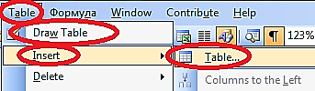

a

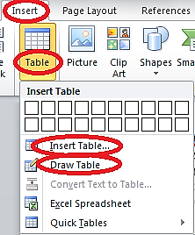

b

Fig. 11 – Table tools in MS Word of MS Office 2003 (a), MS Word of MS Office 2010 (b)
Tables should have captions and be numbered. Numbering of tables may be cross-cutting across all sections or two-level, where the first level is the number of section and the second one begins anew in each new section. The caption format is: «Table»-NON-BREAKING SPACE-«Table number»-EM DASH-NON-BREAKING SPACE-«Caption». A table caption is arranged at the top of a table. The table and corresponding caption should be separated from the top and the bottom by an empty string with the style «Jnep_Empty_string». Caption style is «Jnep_Caption». The text style in a table is «Jnep_Normal». If necessary, the font size can be reduced. The corresponding example:

Table 2 – Table caption

Too cumbersome tables are inserted in a way described in subsection 4.4.

Aknowledgements

Authors are grateful to the Editor-in-Chief of the Journal of Nano- and Electronic Physics Protsenko Ivan Yuhymovych for a critical reading of the manuscript and his valuable comments.

Appendix А
Century SchoolBook FONT INSTALLING

- Download the archive with necessary font from the Journal website.
- Unpack and remove its content into the folder C:\WINDOWS\Fonts.
- Check the Century SchoolBook font availability in the font dialog of MS Word. In case of need – reload the MS Word.

REFERENCES

- P. Reimann, Phys. Rep. 361, 57 (2002).
- T.V. Lyutyy, A.Yu. Polyakov, A.V. Rot-Serov, C. Binns, J. Phys.: Condens. Matter 21, 396002 (2009).
- G.S. Vorobjov, V.O. Zhurba, A.S. Krivets, J. Nano- Electron. Phys. 2 No4, 47 (2010).
- H. Gould, J. Tobochnik, Computer Simulation Methods. Applications to Physical Systems (New York: Addison-Wesley Publishiong: 1988).
- Precision Alloys: Handbook (Ed. B.G. Molotilov) (Moscow: Metallurgy: 1983).
- W. Ebeling, F. Schweitzer, arXiv:cond-mat/0211606v2.
- Ya.O. Suchikova, V.V. Kidalov, G.O. Sukach, Pat. 93456, Ukraine, MPK(2006): G01N 27/00, publ. 10.02.2011, bull. No 3/2011.
- V.V. Kulish, A.C. Melnyk. Pat. US 6,653,640 B2, USA, publ. 25.11.2003.
- G.B. Stephanovich, Thin films in the Optics and Electronics, 263 (Kharkiv: NNC KhFTI: 2003).
- V.V. Starostenko, E.P. Taran, 17th International Crimean Con-ference – Microwave and Telecommunications (CRIMICO-2007), art. No 4368895, 667 (Sevastopol: Veber: 2007).

lyutyy@oeph.sumdu.edu.ua
alexander.p1987@gmail.com

